Lab 3

Tony Sommer

In lab 2 I made a simple jQuery Mobile app that uses the Google Maps web service. In this app there are two buttons, one says Kansas City, the other says St. Louis.

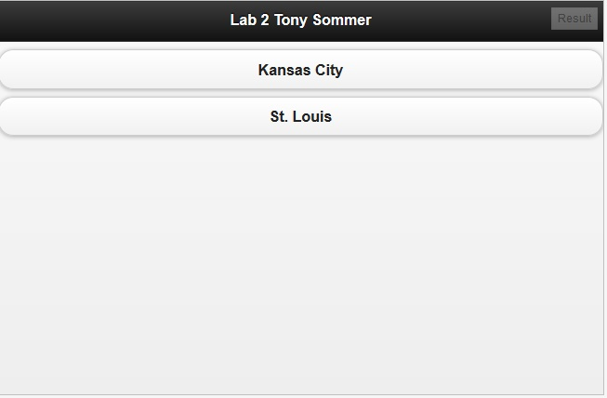

When you click Kansas City it pop ups a map centered on Kansas City, and the same for St. Louis. Or, at least it should…

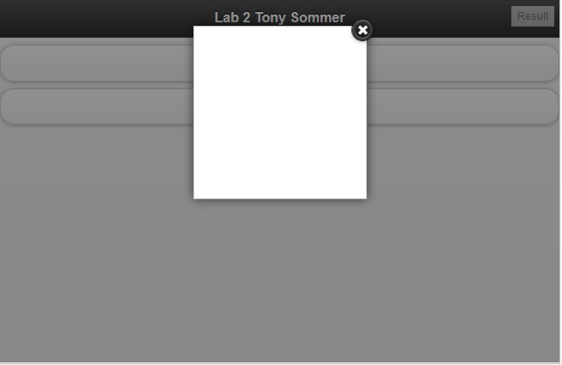

The maps didn’t work in the mobile version, but did work if I did it in a normal webpage using the same code.

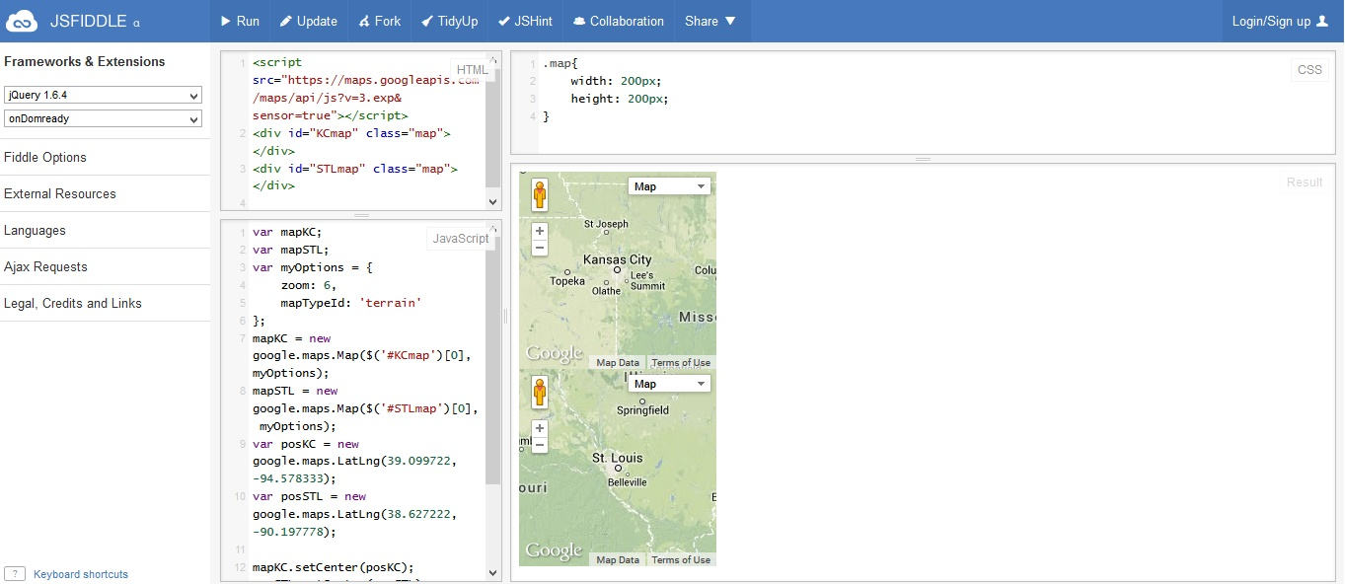

In lab 3 I “extended” it by simply changing the way these maps were drawn. I created a web service that would return the latitude and longitude with a given city name, and used this web service to create a Mashup (combining that web service and the Google Maps web service). When calling my web service it stores the responses locally.